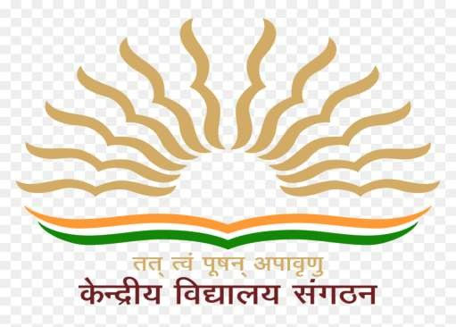

ANNUAL ACADEMIC CALENDER
2021-22

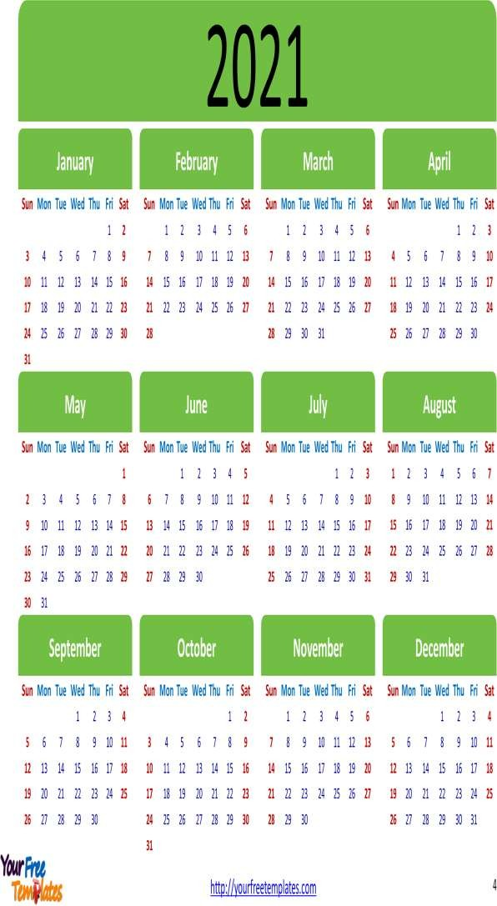
2021-22

KV. PRAGATI VIHAR

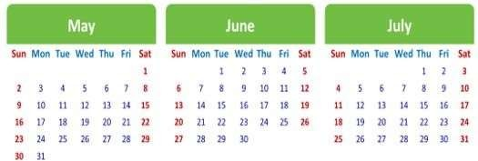
2022
MARCH
FEBRUARY
JANUARY

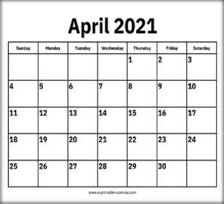

LIST OF ACTIVITIES PLANNED:

1. Welcome and Beginning of New Academic Session 2. Registration for Class 2nd And Above as Per Vacancy Available
- Verification of UBI Data and Collection of Fee For 1st

Quarter

- Distribution of Student Diaries and Form 16 To Employees 5. Operationalize House System and Introduction of Calendar of Activities.
- Meeting of Rajbhasha Hindi Committee.

- distribution of split up syllabus.

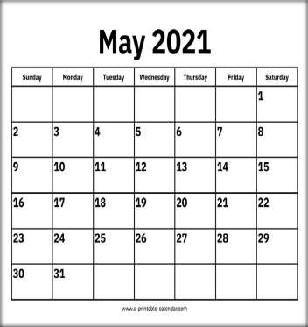

LIST OF ACTIVITIES PLANNED

  - Assignments to students for vacation (Summer closing Vidyalaya’s)
  - Planning for maintenance and repair work of building, furniture & Safety Audit Certificate of Vidyalaya building, Fire etc.
  - Summer vacation starts (Summer Closing Vidyalaya’s)

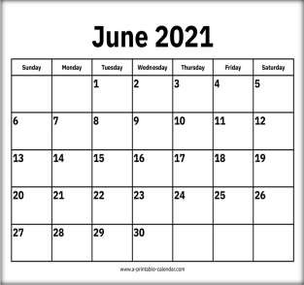

LIST OF ACTIVITIES PLANNED:

- Resuming the normal work after vacation (Summer Closing Vidyalaya’s)
- Summer vacation ends (Summer Closing Vidyalaya’s)
- Verification of UBI data
- Investiture Ceremony for the House and School Captains/Students Council
- Celebration of International Yoga Day

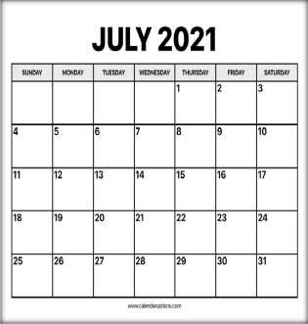

LIST OF ACTIVITIES PLANNED:

- Collection of fees for second quarter through UBI
- Environment /Plantation/Book Week/Van Mahotsova
- Ek Bharat Shrestha Bharat and Science Exhibition at school level
- Publication of Vidyalaya Patrika (before 31st July for the
previous academic session)
- Meeting of Rajbhasha Committee

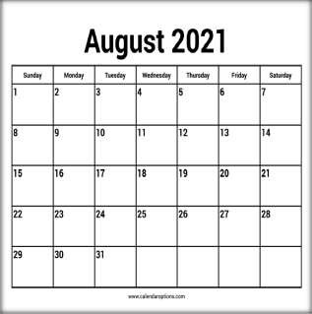

LIST OF ACTIVITIES PLANNED:

- Celebration of Independence
- Celebration of Sanskrit Week
- Ek Bharat Shrestha Bharat Parv
- Health checkup
- Conduct of VMC meeting
- Parents- Teachers meeting

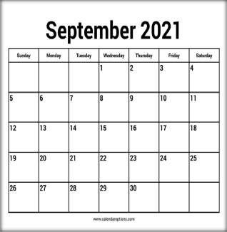

LIST OF ACTIVITIES PLANNED:

- Celebration of Teacher’s Day
- Celebration of Hindi Diwas and Pakhwada
- Maths Olympiad
- Annual Sports Day
- Swachhta Pakhwada

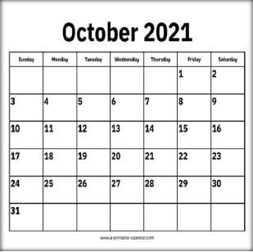

LIST OF ACTIVITIES PLANNED:

- Gandhi Jayanti Celebration/Grand Parent’s Day
- Colection of fees for third quarter through UBI
- Half Yearly for Summer Stations.
- Vigilance Awareness Week (ends 31st),
- Celebration of Rastriya Ekta Diwas
- Meeting of Rajbhasha Committee
- Conduct of National Children Science Congress.

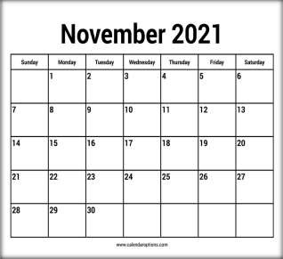

LIST OF ACTIVITIES PLANNED:

- Children’s Day Celebration.
- National Education Day (11th November)
- Celebration of Constitution Day (26th Nov.)
- Celebration of Communal Harmony Week.

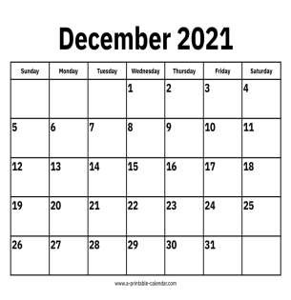

LIST OF ACTIVITIES PLANNED:
  - National Energy Conversation Day (14thDecember)
  - K.V.S. Foundation Day (15th December)
  - Conduct of VMC meeting
  - Assignment to students for Vacation/Summer closing Vidyalaya
  - Verification Level Sports Day.

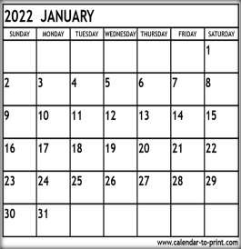

LIST OF ACTIVITIES PLANNED:

- Parent- Teacher Meeting
- Republic Day Celebration
- Periodical test II for Summer Station
- Meeting of Rajbhasha Committee

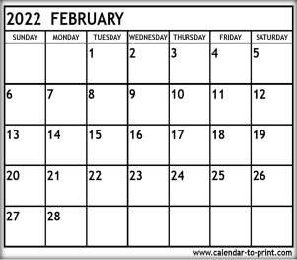

LIST OF ACTIVITIES PLANNED:

  - Notification and registrationforadmissiontoclass 1standother classes.
  - Conduct interview for contractual appointments.
  - Conduct of VMC meeting in first week
  - Cubs and Bulbul Utsav / celebration of Thinking Day.
  - Health check up
  - Online admission starts.

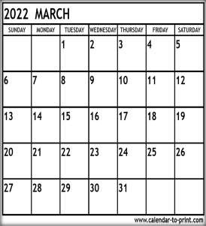

LIST OF ACTIVITIES PLANNED:

- Board Exam and Session Ending Examination for all classes
- Printing of Student’s diaries and Teacher’s diaries for next session.
- Planning for the next session.
- Declaration of result.
- Admission as per KVS schedule.
- Framing of Time-Table for new session.
- Finalise the list of class teachers &co-class teacher
- Preparation ofannual VVN budget
- Staff meeting.
- Preparation of the calendar of C.C.A. & sports activities. 11.Physical verification of stock.
- Addition of new admissions in UBI (class 1)
- Class one admission.

